Margarita Geleta, Ibrar Malik

Mathematical Optimization | Data Science

Pattern Recognition

WITH SINGLE LAYER NEURAL NETWORK

We define in *Python* as follows:

|  |
| --- |
| **def** **sigmoid**(x):  **return** 1. / (1. + np.exp(-x))  **def** **y**(X, w):  **return** **sigmoid**((**sigmoid**(X) @  w.T)) |

**Network training**

Now the big question is: how do we get our neural network to learn? It is going to learn from errors. Thus, we need to define an “*error/loss function*”. Before formulating that function, note that we are going to use a set of numbers to train our network and a separate test for testing the predictions. These sets are called *training ($X^{TR},y^{TR}$)* and *test* ($X^{TE},y^{TE}$) sets, respectively.

The loss function is defined as follows:

$$L\left(X^{TR},y^{TR} \right)=\sum_{j=1}^{p}{{\left(y\left(x_{j}^{TR},w\right)-y_{j}^{TR}\right)}^{2}}$$

being $p$ the size of the training set. We can also add a regularization parameter $λ$ (of type *L2*):

$$\tilde{L}\left(X^{TR},y^{TR} \right)=L\left(X^{TR},y^{TR} \right)+λ∙\frac{{\left\|w\right\|}^{2}}{2}$$

We define them in *Python* in one method. If $λ$ = $0$, then we return $L\left(X^{TR},y^{TR} \right)$, otherwise we return $\tilde{L}\left(X^{TR},y^{TR} \right)$ with its corresponding regularization parameter $λ$:

|  |
| --- |
| **def** **loss**($w$, $X^{TR}$, $y^{TR}$, $λ$ =0):  **return** np.linalg.norm(y($X^{TR}$, $w$)  – $y^{TR}$)**2 + $λ$/2 *  np.linalg.norm($w$)**2 |

To train the network, i.e. find the optimum $w$, we need to minimize $L\left(X^{TR},y^{TR} \right)$ with some optimization algorithm. To minimize the loss function, we need its gradient:

$$\frac{∂\tilde{L}\left(X^{TR},y^{TR} \right)}{∂w_{i}}=\sum_{j=1}^{p}{2∙\left(y\left(x_{j}^{TR},w\right)-y_{j}^{TR}\right)∙y\left(x_{j}^{TR},w\right)∙\left(1-y\left(x_{j}^{TR},w\right)\right)∙\left(\frac{1}{1+e^{-x_{ij}^{TR}}}\right)+λ∙w_{i}}$$

|  |
| --- |
| **def** **g_loss**($w$, $X^{TR}$, $y^{TR}$, $λ$ =0):  **return** np.squeeze(2 *  sigmoid($X^{TR}$.T) @  ((y($X^{TR}$, $w$) – $y^{TR}$) *  y($X^{TR}$, $w$) * (1 –  y($X^{TR}$, $w$))) + $λ$ $w$*.T) |

**About the project**

The aim of the project is to build a *Single Layer Neural Network* (abbreviated as *SLNN*) from zero in *Python* that would be capable of recognizing a set of target numbers. The numbers from the [0,9] interval will be used as targets. Each number has a 7*x*5 pixel matrix representation, with values 0 and 1 (*figure 1*).

|  |  |  |
| --- | --- | --- |
| /var/folders/sc/wk95ry317zj7gtv9yxmtgxl00000gp/T/com.microsoft.Word/Content.MSO/135484DD.tmp | /var/folders/sc/wk95ry317zj7gtv9yxmtgxl00000gp/T/com.microsoft.Word/Content.MSO/A1CFCD3A.tmp | /var/folders/sc/wk95ry317zj7gtv9yxmtgxl00000gp/T/com.microsoft.Word/Content.MSO/DFC87F3.tmp |
| /var/folders/sc/wk95ry317zj7gtv9yxmtgxl00000gp/T/com.microsoft.Word/Content.MSO/9AB8B958.tmp | /var/folders/sc/wk95ry317zj7gtv9yxmtgxl00000gp/T/com.microsoft.Word/Content.MSO/8ED27979.tmp | /var/folders/sc/wk95ry317zj7gtv9yxmtgxl00000gp/T/com.microsoft.Word/Content.MSO/F9E76126.tmp |
| /var/folders/sc/wk95ry317zj7gtv9yxmtgxl00000gp/T/com.microsoft.Word/Content.MSO/5E2B12EF.tmp | /var/folders/sc/wk95ry317zj7gtv9yxmtgxl00000gp/T/com.microsoft.Word/Content.MSO/CB123024.tmp | /var/folders/sc/wk95ry317zj7gtv9yxmtgxl00000gp/T/com.microsoft.Word/Content.MSO/429EC9D5.tmp |

**Figure 1:** Pixel matrix representation of [0,9] numbers.

**Network architecture**

Our neural network is a *perceptron*, that is, a single neuron model, in our case, with 35 entries – all the pixels of a number stored in the input vector $x$. Then, $x$ combined with the vector of weights $w$ and finally, the *sigmoid function* is applied to obtain a binary output 0/1.

So, our neural network ($y$) is defined as:

$$y\left(x,w\right)≔\frac{1}{1+e^{-(\sum_{i=1}^{n}{w_{i}∙σ\left(x_{i}\right)})}}$$

**Figure 2:** Architecture of a perceptron (SLNN) with a sigmoidal activation function.

$$\frac{1}{1+e^{-x^{T}∙w }}$$

0/1

round()

|  |
| --- |
| *x1* |
| *x2* |
|  |
| *xd* |

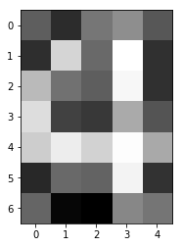

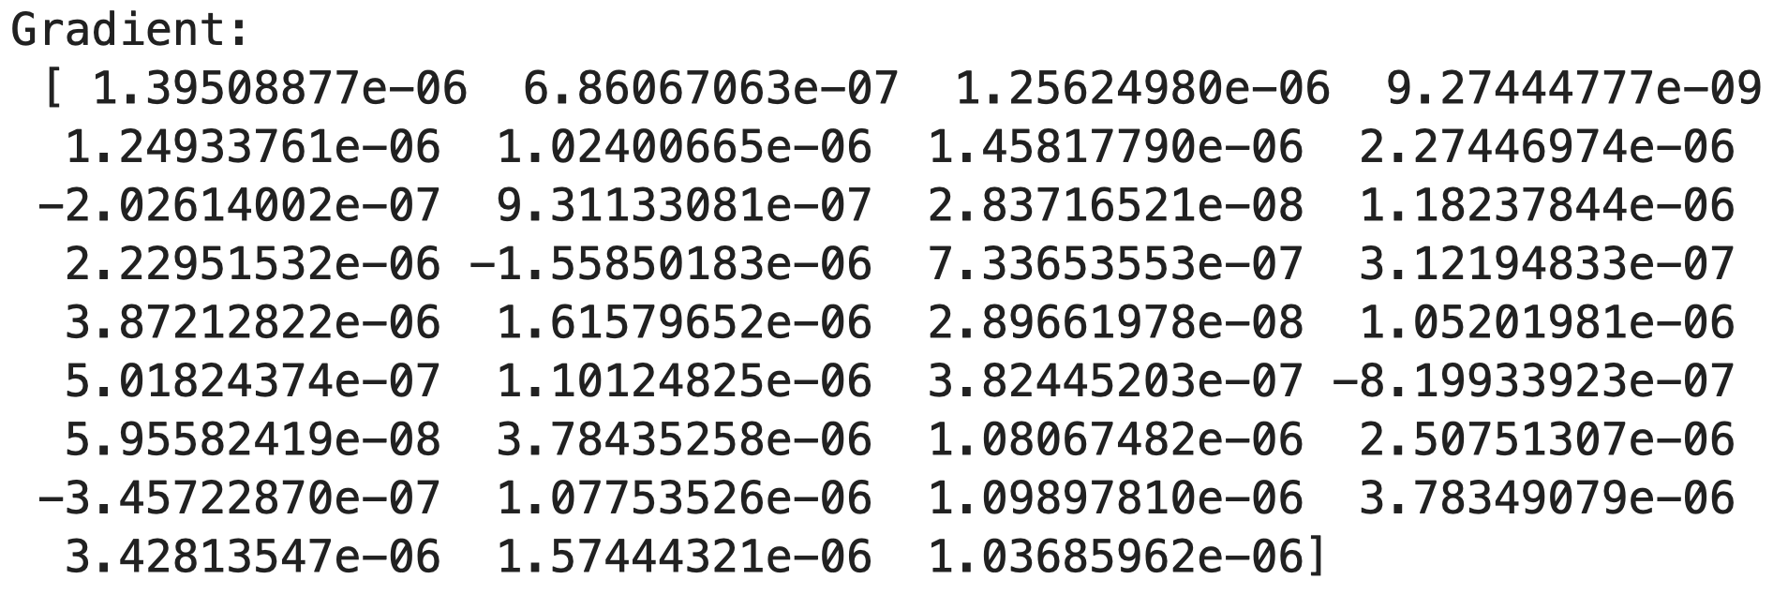

Solving with *Conjugate Gradient Descent* (CGM), Fletcher-Reeves variant without restart condition yields a result in just 4 iterations, which is really fast:





Eventually, we solve it by *Broyden-Fletcher-Goldfarb-Shanno* (BFGS), we finish in 8 iterations, but the accuracy is a bit smaller (<100%) than in the first two methods:





**Solving for target = [4]**

Now that we are ready – we have the objective function $L\left(X^{TR},y^{TR} \right)$, the first-derivative optimization algorithms which we have implemented during this course (GM, CGM and BFGS), the data sets $X^{TR},y^{TR}$ and $X^{TE},y^{TE}$– we can solve the pattern recognition problem for any set of numbers. We are going to start with the target set [4]. The training data set for this problem:

* Has 500 observations (p = 500).
* Train frequency = 0.5
* Noise frequency = 0.1

The hyperparameters for optimization defined for this problem are the following:

* $λ$ = 0.0 (*L2* regularization).
* $ε$ = 1.0e–0.6
* $k^{max}$ = 1000 (iterations).

The hyperparameters for *line search*:

* $α_{0}^{max}=1$ initially. Later on, we update it by $α_{k}^{max}=\frac{2\left(f^{k}-f^{k-1}\right)}{∇f^{k^{T}}∙d^{k}}$.
* $c_{1}$ = 0.01
* $c_{2}$ = 0.45
* $ε$ = 1.0e–0.6
* $k^{max}$ = 500.

First, we use the *Gradient Descent* (GM) algorithm to minimize the loss function in the neural network.

|  |
| --- |
| $X^{TR}$, $X^{TE}$, $y^{TR}$, $y^{TE}$ =  gen_data(123456, 500,  [4], 0.5, 0.1)  net = SLNN()  net.train("GM", $X^{TR}$, $y^{TR}$)  net.summary($X^{TE}$, $y^{TE}$) |

The output (300 iterations):



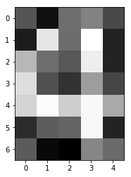



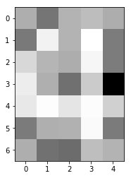

**Solving for target = [8]**

Now that we are ready – we have the objective

